MANNA Client Data Reporting Toolkit

The following toolkit is meant to give an easy step-by-step process for how to enter your client data. We welcome your feedback on the new process and these instructions

Please note: There are a few changes in the data reporting process that we are asking our partners to follow:

Client & Household Counts

- For Pantries: We ask that every pantry report TOTAL Households & Individuals – even if they are duplicated. So if a single mother with 3 children visits your pantry twice in a month, that would count as 2 Households and 8 Individuals. You count them each time they come in.

- For Community Meal Programs: Similar to pantries, MANNA would like to know the TOTAL number of meals your agency has served to clients in a given month. For each meal (Breakfast, Lunch & Dinner), please report how many times each meal was held (e.g. Your agency held 2 community dinners and 1 lunch in a month and 100 people came to each, you would report 300 Total Clients Served – even if they were the same 100 people at each).

- For Senior Centers, Rehabilitations, Residential Facilities, Group Homes& Youth Programs: While the number of program participants might fluctuate during a given month, please report the number of clients based on how many received assistance during the month – even if they were there for one day. Total meals served will be based on daily amounts over the course of the month (e.g. A Senior Care Center has 10 residents who were served Breakfast, Lunch & Dinner every day over a 30-day month. They would report 30 Breakfasts Served, 30 Lunches Served & 30 Dinners Served but only 10 clients in the program. However, if a Youth Program served snacks to 10 different kids every weekday of a month, they would report 20 Snacks Served and 200 Clients.

- Demographics/Agencies Serving Multiple Categories: If your agency hosts both a Pantry and a Meal Program, you may report their numbers within each of the respective categories. However, the demographics that you reports should be based on the make-up of your entire client base on an individual basis (e.g. During the month, 100 people visited your agency – 20 got only food boxes from the pantry, 45 got only meals from a community dinner & 35 got both food boxes and attended a meal. Your agency would report giving out 55 food boxes and having served 80 meals.)

Items of Note

- Deadline for Statistics: Monthly client data MUST be submitted by the 7th of the following month.

- Submit stats even if no service is provided within a given month.
  - Enter “0” for all client data.

Agency Statistics Tab

To begin, log in to your Online Ordering account. A link to the Online Ordering webpage can be found in the ‘For Agency’ section of the MANNA FoodBank website (www.mannafoodbank.org) or it can be accessed via the following link: https://orders.mannafoodbank.org/primariusww/login.aspx
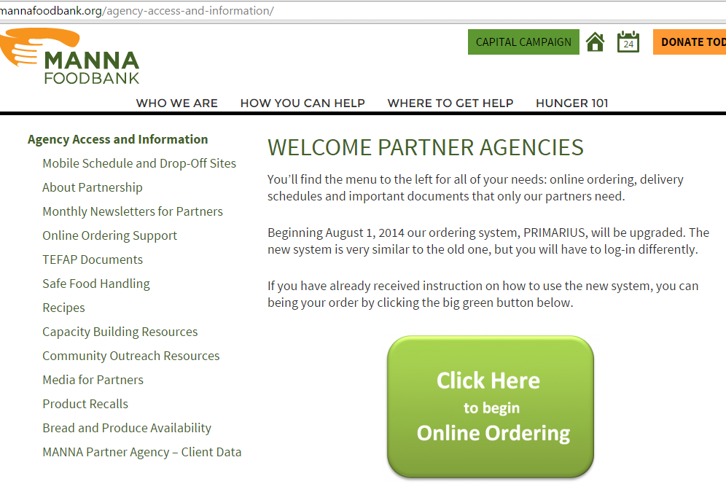

Once logged in and on your agency home page, click the third tab labeled ‘Statistics’

Statistics Home Page

From the Statistics Home Page, you will be able to view prior data entries as well as input data for the prior period. To input your monthly stats, click the ‘Enter Statistics’ button on the lower right.

Pantry Programs

Remember, for Pantry Programs, enter the Total Households and Individuals – Regardless of how many times a client came to your agency.

Example:
20 Households visited once
5 Households visited twice

Soup Kitchens & Welcome Tables

Agencies that provide On-Site Emergency Meals will report their data as follows:

- For Soup Kitchens & Community Meals, the data will be entered as such (assume this agency had two community dinners during the month):
60 people attended a weekly community dinner. 4 dinners took place during the month.

Non-Emergency On-Site Meal Programs

- For Residential Facilities, Group Homes, Senior Centers, Youth Programs & Rehabilitation Centers, the data will be entered more like this:
25 People Are Enrolled In This Program. The Program Serves Breakfast on Weekdays, Lunches Every Sunday & Dinner Every Night. Over a 30-day Month, this is how many meals would be served.

Submitting Monthly Data To MANNA

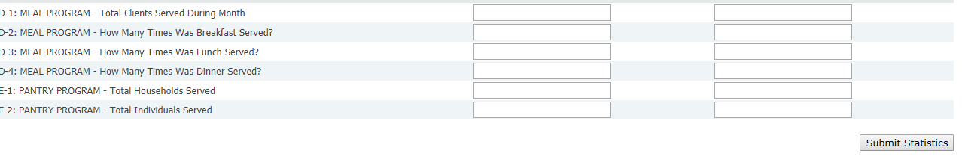

Once you have entered all of your agency data, click the ‘Submit Statistics’ button. Once the data has been submitted it cannot be edited. If you need to make any changes to your monthly data, please call MANNA at 828-299-3663, Ext. 1272.

Confirmation of Data Submission

Once your monthly data has been submitted, you will get a confirmation notice and be able to print out a pdf version of your monthly client data.

Your monthly client data is also now available for viewing
anytime back at the Statistics Home Page
