Media Release

Contact: Billie Smith, Pantry Director
billiesmilth@fbcfp.org | (828) XXX-XXXX

FOR IMMEDIATE RELEASE
The Boy Scouts Are Keepin’ It Cool for the Food Bank

THERESVILLE, N.C. (February 13,2015)

The local Boy Scout troop #123 will be testing out their winter camping gear next Saturday on the roof of the local food pantry, Food for All at the First Baptist Church. The scouts are raising awareness about the plight of those in poverty this winter season, and they are fund raising the get the pantry shelves stocked.

The scouts have committed to spending the night on the roof to remind us of those forced to sleep in the cold due to homelessness, after that they are counting on their community to help them get down. They have a goal of raising $1,000 for the food pantry and have sworn that they’re not coming down without it! The scouts have collected some funds before the event, on Saturday they’ll be calling more businesses and members of the community to reach their goal.

“At least we have good winter gear and can cook on a camp stove, that’s a lot more than some folks have,” says Shawn Brenner, a scout from troop #123. “The pantry said $1,000 would help them make up almost 3,000 meals. That makes me feel like I’m really making a difference helping.” The scoutmaster, Robert Jones, loves how the scouts get into it, the pantry director, Billie Smith, really appreciates the food, “after the holidays, our supplies tend to dip really low.”

If you want to donate and/or help the Food for All Pantry at the First Baptist Church and troop #123, please call Robert Jones at (828) 544-2334 or rjones@bscouts.org, for inquiries with the pantry, please contact Billie Smith at (828) 442-3965 billiesmith@fbcfp.org The pantry is open every Monday and Wednesday at 12 Church St from 12-6pm for those in need of food.
###

About First Baptist Church Pantry in Oakville
The First Baptist Church Pantry in Oakville is a 501(c)(3) non-profit organization serving Shawnee County . It was established in 1998 when the Jr. High class decided to do a food drive. What started with a few pounds of canned goods has turned into a community service project that has distributed over 200,000lbs of food since it began keeping records in 2005. The pantry serves anyone in the community stating a need for food and is a partner in the MANNA FoodBank Network which is also a part of the Feeding America network

About MANNA FoodBank
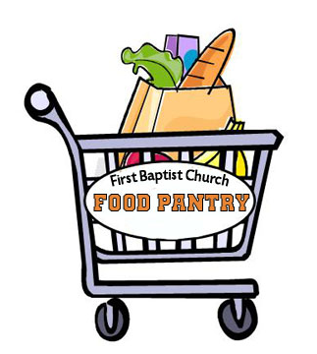 | Media Release  FOR IMMEDIATE RELEASE
MANNA FoodBank is a 501(c)(3) non-profit organization serving Western North Carolina since 1983. As an accredited member of Feeding America, the nation’s largest domestic hunger relief organization, the mission of MANNA FoodBank is to involve, educate, and unite people in the work of ending hunger in Western North Carolina. MANNA serves 248 non-profit member agencies in 16 Western North Carolina counties and distributed more than 15 million pounds of food in 2014. To view MANNA’s Annual Report for 2014, or for more information, visit MANNAFoodbank.org or call 828-299-FOOD.

