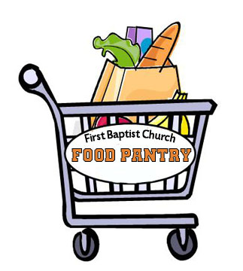 | Media Release  Contact: Billie Smith, Pantry Director  billiesmilth@fbcfp.org | (828) XXX-XXXX  FOR IMMEDIATE RELEASE
Your Title Here

ASHEVILLE, N.C. (Month-Day-Year)

The short and sweet part of the story goes here. It should have an interesting story “hook” or some impressive, eye catching or heartfelt info. – but the short story. This should be one paragraph between 2-4 sentences long (approximately).

Here is the main body of the release that gives more of an expanded story about what the first paragraph mentions. It should also include more practical info about your pantry – where it is, how many families you serve, who you serve. This main body could be two or three paragraphs long. Just include the “meat” of the story. The journalist may decide to do a whole different angle on the story themselves, or they may just copy and paste what you write exactly. This is where you get all of what you want to be included in. Remember, you should only have ONE main focus of the piece. All of the other information should support this focused idea. Too many extra details will just distract from the main idea.

“A good press release will likely have at least one quote,” says Amy Meier, the Buncombe County Outreach Coordinator for MANNA. So seriously, a good quote goes a long way. People you might want to quote would be a pantry director/manager, a pantry volunteer, a pantry recipient or a pantry donor.

You can attach a picture or two if you have good ones. Try to make the entire text of the press release only one page. At the end you should use the “boilerplate” information about your organization and/or MANNA as a network.
###

About First Baptist Church Pantry in Oakville
The First Baptist Church Pantry in Oakville is a 501(c)(3) non-profit organization serving Shawnee County . It was established in 1998 when the Jr. High class decided to do a food drive. What started with a few pounds of canned goods has turned into a community service project that has distributed over 200,000lbs of food since it began keeping records in 2005. The pantry serves anyone in the community stating a need for food and is a partner in the MANNA FoodBank Network which is also a part of the Feeding America network

About MANNA FoodBank
Media Release

FOR IMMEDIATE RELEASE
MANNA FoodBank is a 501(c)(3) non-profit organization serving Western North Carolina since 1983. As an accredited member of Feeding America, the nation’s largest domestic hunger relief organization, the mission of MANNA FoodBank is to involve, educate, and unite people in the work of ending hunger in Western North Carolina. MANNA serves 248 non-profit member agencies in 16 Western North Carolina counties and distributed more than 15 million pounds of food in 2014. To view MANNA’s Annual Report for 2014, or for more information, visit MANNAFoodbank.org or call 828-299-FOOD.

