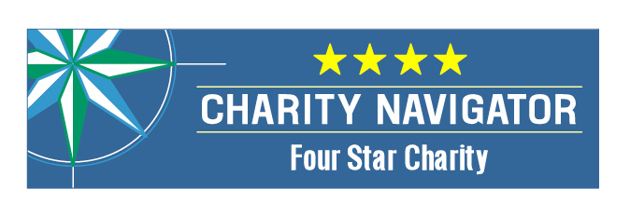
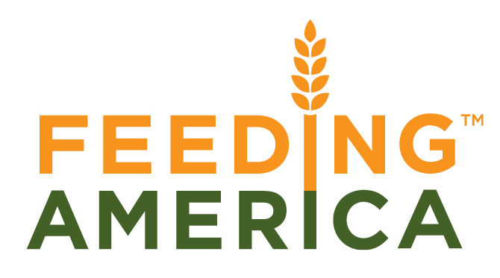
MANNA FoodBank opened its doors in the basement of Eliada Homes in 1983. That first year, the food bank distributed 40,000 pounds of food. In 2014 MANNA distributed 15 million pounds of food, including 3.7 million pounds of fresh produce. That’s enough food to provide 34,000 meals for every day of the year! Still, the need persists. 1 out 6 of our neighbors struggles to put food on the table.
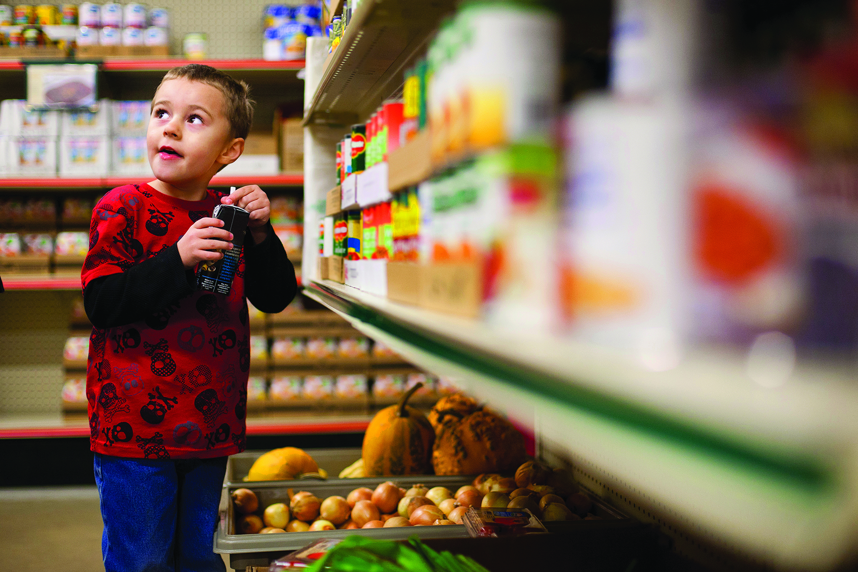
Partnering with MANNA: Together we can solve hunger.
- Give. Every dollar donated to MANNA helps provide enough food for three meals.
- Volunteer. MANNA and the partner agencies could not exist without volunteers. Our dedicated team numbers over 7,500, and in 2014, they gave us 66,278 hours of their valuable time! That’s the equivalent of 31 full-time employees!
- Understand and Advocate. There are many ways to learn more about hunger on a local and national level and about MANNA. Visit MANNAFoodBank.org or call (828) 299-FOOD to schedule a tour of our facilities.

MANNA FoodBank is a member of Feeding America. MANNA was awarded a 4 Star Rating from Charity Navigator. This is the highest rating possible and puts MANNA in the company with the most respected non-profit organizations in the country.
What We Do:
Serve over 200 partner agencies in 16 counties. MANNA supplies food to pantries, soup kitchens, homeless and domestic violence shelters, child and adult daycare centers, and group homes. The food MANNA distributes comes from private donations, public programs, local and national food suppliers.

Deliver MANNA Packs for Kids. One out of four children in WNC lives in conditions of food insecurity-without the continuous access to the basic food they need to live a healthy life. MANNA Packs ensures that each Friday children from low-income households across our service area leave school with a package of food in their backpacks to provide nourishment over the weekend. The program reached an average of 4333 kids in 149 different schools spanning all of 16 counties in our service area.
Outreach that strengthens communities. Food and Nutrition Services (FNS; formerly known as the Food Stamp Program) is an effective and efficient way to prevent hunger. This program reduces the odds of severe and moderate food insecurity and improves the chances that a child will experience healthy development. In 2014, MANNA’s outreach efforts assisted 1,284 households with applications for FNS. An important component of this outreach effort is the new MANNA Food HelpLine. Clients can receive help locating pantries and applying for assistance by calling 1-800-820-1109, Monday through Friday from 9 a.m. to 4 p.m.
The Mission of MANNA Food Bank is to involve, educate, and unite people in the work of ending hunger in Western North Carolina.
The VISION of MANNA FoodBank is a hunger-free WNC.

