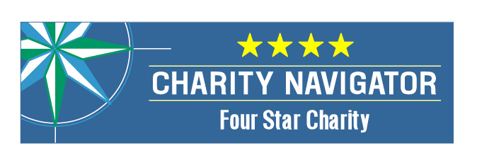
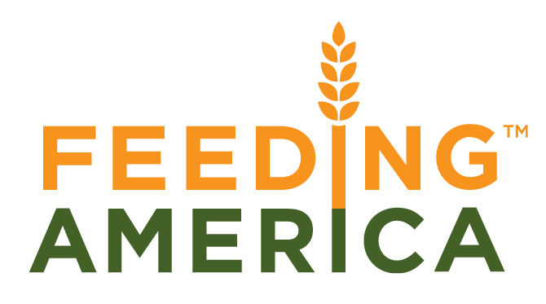
MANNA FoodBank opened its doors in the basement of Eliada Homes in 1983. That first year, the food bank distributed 40,000 pounds of food. In 2013 MANNA distributed 12.8 million pounds of food, including 2.9 million pounds of fresh produce. That’s enough food to provide 1,100 meals for every hour of the day, every day of the year! Still, the need persists. 1 out 6 of our neighbors struggles to put food on the table.
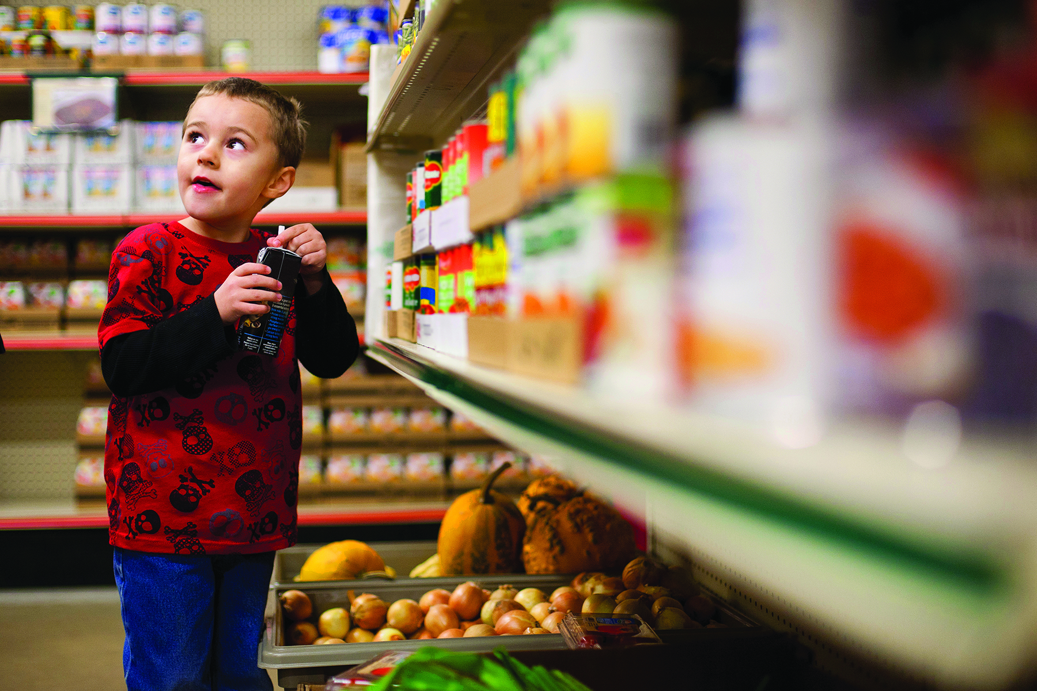
Partnering with MANNA: Together we can solve hunger.
- Give. Every dollar donated to MANNA helps provide enough food for three meals.
- Volunteer. MANNA and the partner agencies could not exist without volunteers. Our dedicated team numbers over 6,900, and in 2013, they gave us 56,754 hours of their valuable time!
- Understand and Advocate. There are many ways to learn more about hunger on a local and national level and about MANNA. Visit MANNAFoodBank.org or call (828) 299-FOOD to schedule a tour of our facilities.

MANNA FoodBank is a member of Feeding America. MANNA
was awarded a 4 Star Rating from Charity Navigator. This is the highest rating possible and puts MANNA in the company with the most respected non-profit organizations in the country.
What We Do:
Serve over 200 partner agencies in 16 counties. MANNA supplies food to pantries, soup kitchens, homeless and domestic violence shelters, child and adult daycare centers, and group homes. The food MANNA distributes comes from private donations, public programs, local and national food suppliers.

Deliver MANNA Packs for Kids. One out of four children in WNC lives in conditions of food insecurity-without the continuous access to the basic food they need to live a healthy life. MANNA Packs ensures that each Friday children from low-income households across our service area leave school with a package of food in their backpacks to provide nourishment over the weekend. The program reached an average of 4600 kids in 132 different schools spanning all of 16 counties in our service area.
Outreach that strengthens communities. Food and Nutrition Services (FNS; formerly known as the Food Stamp Program) is an effective and efficient way to prevent hunger. This program reduces the odds of severe and moderate food insecurity and improves the chances that a child will experience healthy development. In 2013 MANNA’s outreach efforts assisted 997 households with applications for FNS, resulting in an estimated $900,000 in estimated benefits to recipients. This translates to an influx of approximately $1,600,000 for our local economy.
The Mission of MANNA Food Bank is to involve, educate, and unite people in the work of ending hunger in Western North Carolina.
The VISION of MANNA FoodBank is a hunger-free WNC.

